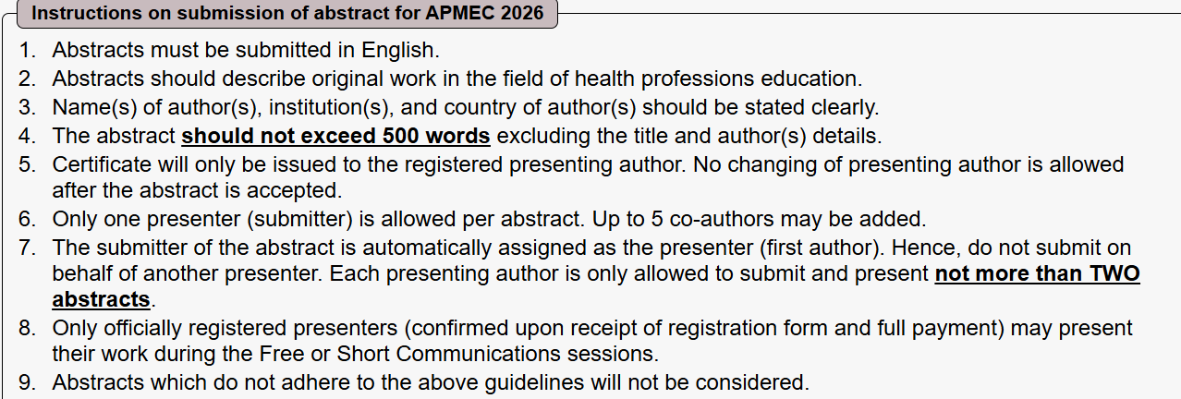

Personal Particulars
Email
Secondary Email
Salutation
Given Name
Last Name
Designation
Country
Institution
Faculty
Department
Address
Zip Code
Telephone Number

Co-authors (up to 5)
Given Name | Family Name | Institution | Faculty / School / Centre | Department | Email | Country

Abstract
Abstract title:

Abstract content (up to 500 words in total):
Please exclude the title and author(s) details.
The abstract should be written in prose form without any special format such as lists or tables. Do not include references or repeat your headings in the text box.

Background and Aims

Methods

Results

Conclusion

Keywords (at least 1, up to a maximum of 5)
1.
2.
3.
4.
5.

Select CATEGORY of Abstract (You may select up to 3)
Faculty Development
Assessment
Simulation and Standardised Patient
Management and Leadership
Teaching and Learning Methods (including TEL)
Interprofessional Education and Collaborative Practice
Scholarship of Education
Curriculum Development
Quality Assurance and Programme Evaluation
Equality, Diversity & Inclusivity
Sustainability
Student and Faculty Wellbeing
Others, please specify:

Young Scholar Award
Presenters of abstracts selected for the Free Communications session will also be eligible for the Young Scholar Award if they are below 35 years old of age as at 21 Jan 2026.
The award will be decided by the judges and it will be announced during the closing ceremony.
Please indicate below (highlight)if you would like to be considered for the Young Scholar Award. If you do not wish to be considered for this award, you will still be considered for the other awards (e.g. Best Oral Presenter, etc.) as per the previous conferences.
I would like to be considered for the Young Scholar Award if my abstract is shortlisted for Free Communications
Please provide your DOB:
I do NOT wish to be considered for the Young Scholar Award if my abstract is shortlisted for Free Communications.

Important Information: Please read carefully
Kindly note that:
Email notification on abstract acceptance and presentation category may be sent separately.
You will NOT be able to amend your entries after submitting.
The Committee reserves the right to edit the submitted abstract if necessary.

Consent
Consent for Video Recording and Dissemination of Materials
As a condition of presenting at an APMEC conference, I consent to having my presentation recorded, stored, and redistributed in digital format by APMEC. I understand it is my responsibility to ensure that any images or other media included in my presentation are properly licensed if necessary.
I agree that APMEC and any third parties acting under its instruction may:
1. Record my participation and presentation in connection with the APMEC 2026 Conference.
2. Use the materials such as PowerPoint presentation files or PDF files that I provide to APMEC in connection with these recordings.
3. Publish and distribute these recordings and materials in whole or in part, including posting them on platforms designated by APMEC.
I attest that I will obtain all necessary third-party permissions to grant APMEC the rights stipulated above, including the use of any third-party copyrighted materials used in my presentation or materials.
Yes, I agree to the above (please highlight the text on the left to show your agreement)

Disclaimer *
By submitting my abstract, I hereby fully consent to
- | National University of Singapore (NUS) collecting, using and/or disclosing my personal data in any form and to disclose the same to third parties (including any third party located outside of Singapore) in compliance with the Singapore PDPA 2012 and all subsidiary legislation for the purpose of processing my abstract submission, subsequent registration and payment to APMEC 2026 and all other actions necessary in relation to the conference.
- | Having my photographs and videos taken during APMEC 2026 for the purpose of marketing, publicity, and media/social media. I further consent to the organisers disclosing such photographs and videos to third party media entities (whether in Singapore or otherwise) for publicity purposes and the organisers may identify me by name.

